**Project Design Phase**

**Problem – Solution Fit Template**

|  |  |
| --- | --- |
| Date | 26-05-2025 |
| Team ID | LTVIP2025TMID61039 |
| Project Name | Rental Home: Find Your perfect Home |
| Maximum Marks | 2 Marks |

**Problem – Solution Fit Overview:**

**1. Problem**

* **Tenants’ Challenges**
  + **Difficulty finding verified and updated rental listings.**
  + **Time-consuming property visits due to lack of online booking.**
  + **Insecure or inconvenient rent payment methods.**
  + **Poor communication with landlords.**
* **Landlords’ Challenges**
  + **Reaching genuine tenants quickly.**
  + **Managing multiple properties efficiently.**
  + **Delays in rent collection and documentation.**
  + **Lack of trust between landlords and tenants.**

**2. Solution**

**A digital rental home platform (web & mobile app) that provides:**

1. **Verified Property Listings – detailed info, photos, availability.**
2. **Smart Search & Filters – location, budget, size, amenities.**
3. **Booking & Scheduling – request property visits online.**
4. **Secure Payments – rent, deposits, receipts.**
5. **Digital Lease Management – upload, sign, and store agreements.**
6. **Built-in Communication – chat/notifications for tenants and landlords.**
7. 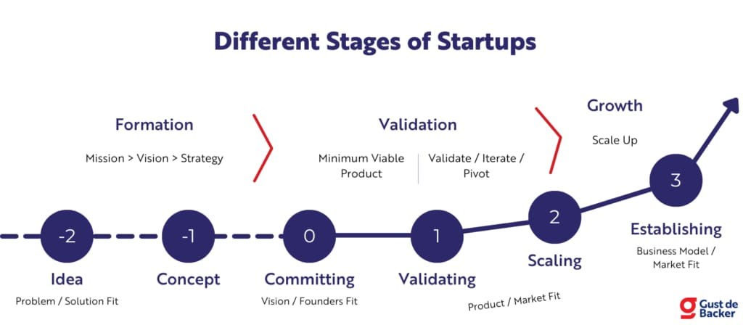
8. **Admin Dashboard – oversight, analytics, and fraud prevention.**

**3. Fit Justification**

* **Tenant Needs → Reliable, fast, transparent home search → Solved by verified listings, filters, and bookings.**
* **Landlord Needs → Quick tenant acquisition and rent management → Solved by dashboards, payments, and documentation tools.**
* **Market Needs → Trust, convenience, digital transactions → Solved by integrated platform with security and transparency.**

**4. Value Proposition**

* **Tenants → Save time, reduce stress, secure payments, reliable homes.**
* **Landlords → Faster occupancy, easier management, secure collections.**
* 